Jonathan Kindberg
BNF0 491
Molecular Biology Through Discovery
Research Proposal
Draft

The NPR-1 protein and acute tolerance to ethanol

(01 December 2012)

- Introduction
Alcohol abuse affects millions of people worldwide. Currently, nearly 14 million Americans (1 in every 13 adults) abuse alcohol or are alcoholic ("Alcoholism Facts." MedicineNet.com. 01 December 2012. http://www.medicinenet.com/script/main/art.asp?articlekey=52888). Current drug treatments are inadequate because the proteins that alter the nervous system when exposed to ethanol are not completely understood. According Bettinger et al (1), this is partially due to the fact that the molecular nature of acute ethanol response is not well understood. Davies et al (2) use C. elegans, a small roundworm to understand the protein interactions in the nervous system of both humans and C. elegans . This animal is a good candidate for experimental procedures because it has a simple nervous system and it uses similar neurotransmitters that are used by the human brain. When C. elegans are exposed to a continuous concentration of ethanol for an extended period of time, they undergo a change in how their neurons respond to the ethanol stimulus, which is known as acute tolerance. This explains why C. elegans appear to be less intoxicated over a period of time. The NPR-1 protein was found within C. elegans to control how these animals regulate acute tolerance to ethanol. NPR-1 protein is a G protein-coupled neuropeptide receptor that is homologous to the mammalian neuropeptide Y (NPY) receptor required for regulating anxiety, food consumption, and pain sensation. In C. elegans, NPR-1 is involved in ethological variations of social behavior such as social versus solitary feeding; in regulating social behavior ("Gene-npr-1." wormbase.org. National Human Genome Research Institute at the US National Institutes of Health and the British Medical Research Council 01 December 2012. <http://www.wormbase.org/species/c_elegans/gene/WBGene00003807?query=npr-1>).

During one experiment Davies et al (2) compared the NPR-1 proteins of C. elegans that were exposed to ethanol for an extended period of time with C. elegans that were not exposed to ethanol. This was achieved through an experimental procedure called “clumping.” This procedure involves placing 20 ethanol induced animals and 20 non-ethanol treated animals inside copper rings placed on separate plates. Inside each copper ring was bacteria lawn or bacteria clump. C. elegans are attracted to the bacteria clump because it’s a natural food source. They then counted the number of animals whose body was 50% on the bacteria clump from both plates. They observed that the ethanol induced animals were less likely to be on the bacteria clump. Finally, each animal’s RNA was isolated using the RNAqueous-4PCR Kit (a kit used to extract RNA). The NPR-1 mRNA levels of both the animals that were not exposed to ethanol and the animals exposed to ethanol were compared in agarose gel.
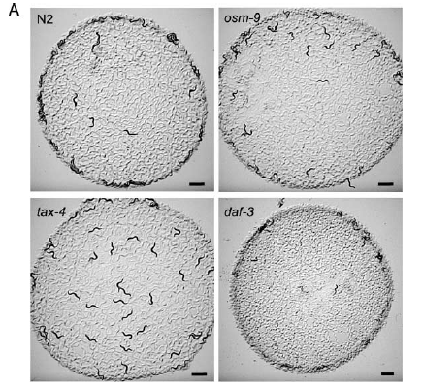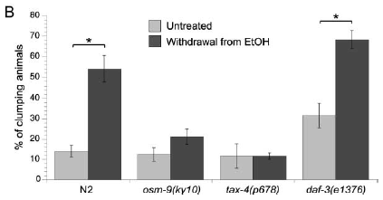

Fig.1 (A) N2 animals do not clump unless induced by ethanol. Daf-3 animal’s clump and border when withdrawn from ethanol. Osm-9 and tax-4 mutant animals show no visible signs of clumping when exposed to ethanol.
(B) The bars represent the percentage of animals clumping following the withdrawal of ethanol.

The results indicated that the two C. elegans strains that were used in the experiment had different functional levels of the NPR-1 protein. The results concluded that the strains with a lower NPR-1 function show a higher dependency for ethanol which is isolated from the animals that were exposed to ethanol. They also observed that prolonged exposure to ethanol mirrors the lower NPR-1 function, which indicates a higher dependency towards ethanol. Based on these results the NPR-1 protein may be able to genetically link alcoholism in humans.
- Experiment
The goal of this experiment is to determine if the same alterations in the NPR-1 protein functions are seen in mice. Humans and mice share the same 20-25k genes, which makes the mice genome about 85% similar to humans. The mice can be selectively bred to isolate specific addictions. As described in the experiment by Martin Davies (5), he used multiple mice which were bred to be affected by ethanol in order to study a different protein receptor called GABA_{A}. Indiana University researchers have been able to selectively breed mice that are addicted to alcohol (4). Theses mice were then used in other experiments relating to gene functions with alcoholism.
The addiction that I will concentrate on in this experiment is mice that display an acute tolerance to ethanol. This experiment will use two different groups of mice. One group of mice will display the tolerance addiction. The second group of mice will not display any addictions. I will then expose both groups of mice to ethanol and compare the NPR-1 protein function of the mice to the C. elegans. I would expect the mice that were selectively bred with tolerance addiction traits to show similar low NPR-1 protein function. This experiment correlates closely with the Mutschler et al (6) experiment regarding ethanol and a low functioning NPR-A (NPR-1) protein. The results indicated that a low functioning NPR-1 protein resulted in increase in alcohol tolerance or dependency.

- Discussion
If my experiment is successful then the NPR-1 function in the mice that have been bred with an ethanol addiction tolerance will exhibit a lower functioning NPR-1 protein. The group of mice that have no addiction will exhibit a higher functioning NPR-1 protein. One problem that may result from this experiment is that the selectively bred mice with addiction traits towards ethanol could have the adverse effect and show a higher functioning NPR-1 protein. The mice that were bred without those addictive traits could show a low functioning NPR-1 protein.
One way to combat this experimental flaw would be to test multiple groups of mice with multiple addiction traits. By increasing the amount of test subjects I would then have more accurate data to show if my predictions were correct. If more than one group of mice with ethanol addiction traits exhibit lower functioning NPR-1, then more conclusions could be drawn from this experiment. I could also use mice that lack a functioning NPR-1 like Mutschler et al to further support my hypothesis that ethanol tolerance is directly related to the function of the NPR-1 (6) protein and may be able to genetically link alcoholism in humans.

- References

1. Jill C. Bettinger, Kapo Leung1, Mia H. Bolling1, Andrew D. Goldsmith4, Andrew G. Davies.
“Lipid Environment Modulates the Development of Acute Tolerance to Ethanol in Caenorhabditis elegans”

2. Davies AG, Bettinger JC, Thiele TR, Judy ME, McIntire SL. "Natural variation in the npr-1 gene modifies ethanol responses of wild strains of C. elegans"
http://www.sciencedirect.com/science/article/pii/S0896627304002922. (Neuron, Volume 42, Issue 5, 10 June 2004, Pages 731–743)
3. Bettinger JC, Goldsmith A, Steven A, Mcintire. “The genetics of acute adaptation to ethanol intoxication in worms” West Coast Worm Meeting (2004) Key: citeulike:3316504
4."Mice Bred at University Have Drinking Habits of Most Severe Alcoholics" Addiction Treatment Magazine. 04 Feb. 2012 <mice-alcoholics>.
5. Davies, M.” The role of GABAA receptors in mediating the effects of alcohol in the central nervous system. J Psychiatry Neurosci” 2003 July; 28(4): 263–274.
6. Mutschler J., Bilbao A., von der Goltz C.H., Jahn H., Spanagel R, Wiedemann K., Kiefer, F."Increased alcohol sensitivity to stress in mice lacking a functional natriuretic peptide-A receptor” European Psychiatry. Volume 23, page 254 (avril 2008)
7. Chin, J.H. and Goldstein, D.B. “Drug tolerance in biomembranes: a spin label study of the effects of ethanol.” Science 196:684 – 685, 1977.
8. Chin, J.H. and Goldstein, D.B. ” Effects of low concentrations of ethanol on the fluidity of spin-labeled erythrocyte and brain membranes. Mol. Pharmacol. 13:435 – 441, 1977.
9. Singer, S. and Nicolson, G.L. The fluid mosaic model of the structure of cell membranes. Science 175:720 – 731, 1972.
10. Mitchell P, Mould R, Dillon J, Glautier S, Andrianakis I, James C, Pugh A, Holden-Dye L, O'Connor V. "A Differential Role for Neuropeptides in Acute and Chronic Adaptive Responses to Alcohol: Behavioural and Genetic Analysis in Caenorhabditis elegans."
(PLoS One. 2010; 5(5): e10422)

